**Calibrating the prison population**

New status quo where the average influx from 2006 and 2014 based on ABS and DCS data were applied for those years in the simulation. A percentage increase obtained from ABS data is then applied from 2014 to 2016. And then from 2016 onwards, the average influx from 2006 to 2016 based on ABS and DCS data was applied.



Figure 1. Simulated NSW prison population wherein the number of new incarcerations is drawn from a distribution acquired from the ABS and the DCS covering the period 2006 to 2014. And a sharp increase in the number of new incarcerations is applied from 2015 onwards to reflect the current incarceration trends.

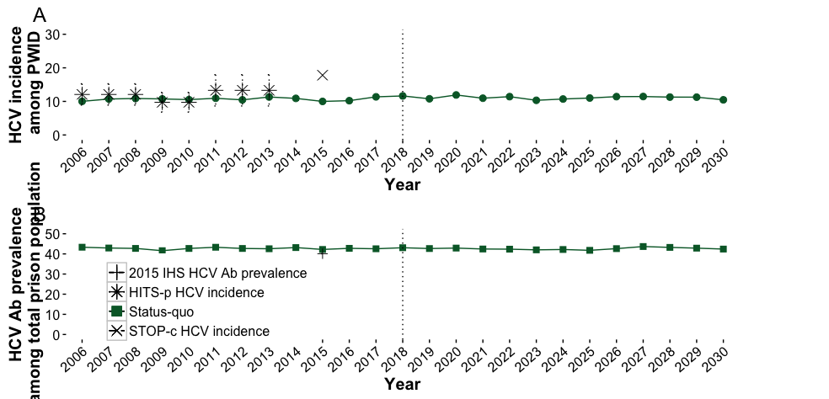

Figure 2. Simulated HCV incidence and prevalence in NSW prisons.

**DAA**

Three scenarios were explored: (i) DAA treatments reduced to 0, (ii) DAA treatments maintained at 1000 per year, and (ii) DAA treatments increased to 2000 per year.



Figure 3. Simulated HCV incidence and prevalence under three DAA scenarios.

**OST**

An improved OST scenario is explored, where OST participation reduces IDU and sharing by 55-75% (Larney, 2010). Three scenarios were explored: (i) distribution of 0% efficacy OST retained at 1400 opioid users per year, (ii) distribution of improved OST to 1400 opioid users per year, and (iii) unrestricted distribution of improved OST to all PWID.



Figure 4. Simulated HCV incidence and prevalence under various OST scenarios.

**NSP**

Based on a 2001 review by Gibson, et al. measuring the effectiveness of syringe exchange programs in reducing HIV risk behaviour and HIV seroconversion, the reduction of syringe sharing among NSP participants is at 25% (15-50%). NSP was implemented by bringing down the probability of syringe sharing of participants by 25% and 50%. Three scenarios were explored: (i) no implementation of NSP, (ii) NSP with 25% reduction in syringe sharing provided to all PWID per year, and (iii) NSP with 50% reduction in syringe sharing provided to all PWID per year.

**Reduction of new incarcerations infected with chronic HCV**

A reduction of new incarcerations infected with chronic HCV was simulated by reducing new prison entrants who are HCV RNA+ at an annual rate from 2018 up to 2030. The annual rate reduction is based on the (intermediate and optimistic) estimates for NSW from the 2018 annual surveillance report. Three scenarios were explored: (i) assuming a maintained influx of people who are HCV RNA+, (ii) assuming annual reduction in new incarcerations who are HCV RNA+ based on intermediate estimates ASR, and (iii) assuming annual reduction in new incarcerations who are HCV RNA+ based on optimistic estimates ASR.

|  |  |  |
| --- | --- | --- |
| **Year** | **Intermediate % reduction from previous year** | **Optimistic % reduction from previous year** |
| 2018 | 11% | 16% |
| 2019 | 10% | 20% |
| 2020 | 11% | 23% |
| 2021 | 13% | 25% |
| 2022 | 15% | 28% |
| 2023 | 18% | 31% |
| 2024 | 20% | 23% |
| 2025 | 22% | 26% |
| 2026 | 28% | 35% |
| 2027 | 38% | 55% |
| 2028 | 63% | 84% |
| 2029 | 89% | 64% |
| 2030 | 72% | 53% |

**Combinatorial strategies**

Five combinatorial strategies were explored where two or more treatment and prevention programs were employed.

1. DAA (optimal) + OST (intermediate)

DAA treatments are increased to 2000 individuals per year and improved OST is distributed to 1400 opioid users per year.

1. DAA (optimal) + OST + NSP (intermediate)

DAA treatments are increased to 2000 individuals per year, improved OST is distributed to 1400 opioid users per year, and NSP with 25% reduction in syringe sharing provided to all PWID per year.

1. Reduction + DAA (optimal)

Assuming annual reduction in new incarcerations who are HCV RNA+ based on intermediate estimates ASR, DAA treatments are increased to 2000 individuals per year.

1. Reduction + DAA (optimal) + OST (intermediate)

Assuming annual reduction in new incarcerations who are HCV RNA+ based on intermediate estimates ASR, DAA treatments are increased to 2000 individuals per year and improved OST is distributed to 1400 opioid users per year

1. Reduction + DAA (optimal) + OST (intermediate) + NSP (intermediate)

Assuming annual reduction in new incarcerations who are HCV RNA+ based on intermediate estimates ASR, DAA treatments are increased to 2000 individuals per year, improved OST is distributed to 1400 opioid users per year, and NSP with 25% reduction in syringe sharing is provided to all PWID per year.

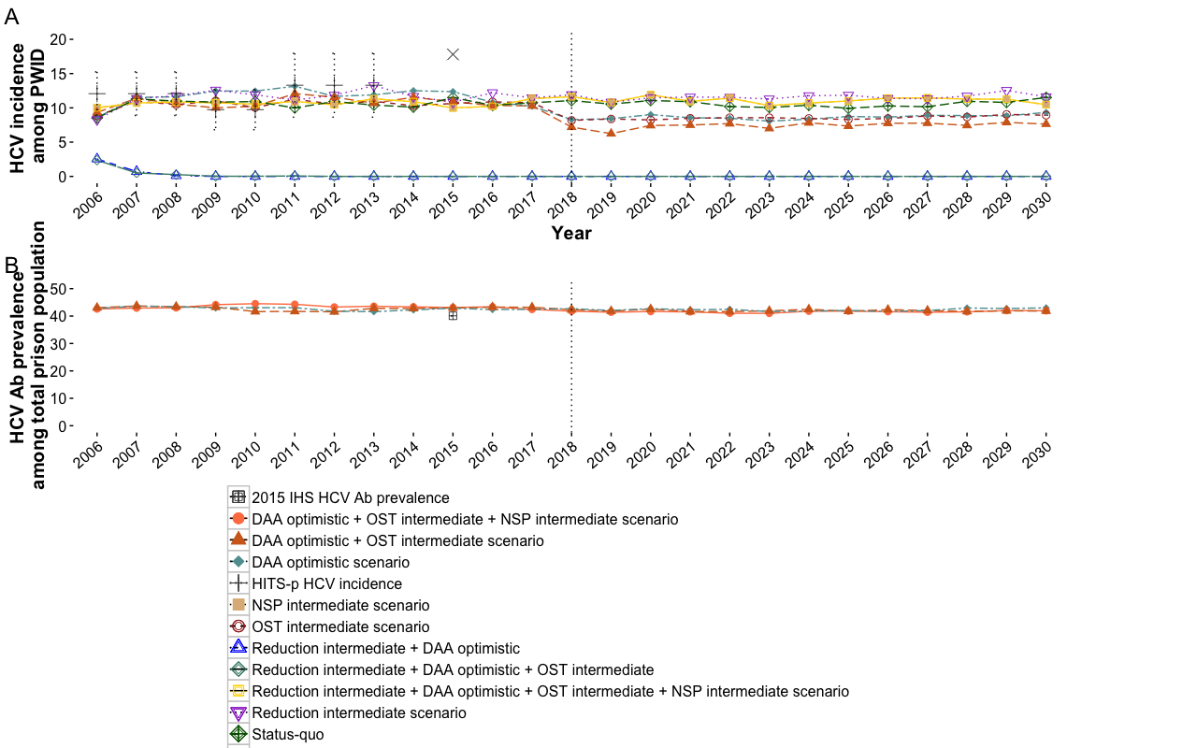

Figure 5. Simulated HCV incidence and prevalence under combinatorial scenarios.